Case Investigation / Problem-Solution Brief
AI Synergy Hackathon 2026 — Round 1, Case 03: Healthcare — "The Follow-Up Blind Spot" — Team Neuromot
Integrity note. Per the case-file integrity note (ABV-IIITM Gwalior / Sangillence, AI Synergy Hackathon 2026), all numerical figures drawn from the official case booklet — OPD volume, the 28% non-return rate, and the 19% / 7% contact figures — are competition materials used to define the problem space, not verified statistics about a real hospital. They are labelled CASE EVIDENCE throughout this brief. Findings drawn from the peer-reviewed EM-TeBa study and other cited sources are independently verifiable and are labelled EXTERNAL EVIDENCE.

1. Map — Stakeholders, Signals, Constraints, Unknowns
Stakeholders (CASE EVIDENCE).
- Patients and caregivers — variable literacy, some share a household phone, some have none, some travel long distances (outstation).
- Doctors and nurses — identify who needs follow-up; must not be replaced in any clinical judgement.
- Registration and records staff — the small team that currently has no way to prioritise manual calling.
- Community health workers (CHWs) — the people who would actually act on a prioritised list.
- Hospital administration — wants the 28% non-return rate reduced without new clinical risk.
Case evidence pack (reproduced from the booklet).
Signal | Case evidence | What remains uncertain
Volume | ~900 outpatient visits/day | How many genuinely require active follow-up
Return rate | 28% of follow-up patients did not return within window (3-month sample) | Which missed visits are clinically important vs. administratively delayed
Contact | 19% shared household number; 7% unreachable | What alternative contact channels are acceptable and consented
Records | Follow-up instructions are free text, varies by clinician | Whether structured capture reduces ambiguity
Staffing | Small records team cannot manually prioritise every missed visit | What prioritisation can be safely automated
Risk boundary | Clinical teams reject autonomous diagnosis, treatment change, or emergency advice | Where the safe workflow/clinical-judgement line sits
Constraints (CASE EVIDENCE). No EHR integration assumed available. Clinical teams will reject any system that independently diagnoses, changes treatment, or gives emergency advice. Staff have limited time for manual calling.
Unknowns. Whether a failed teach-back predicts later loss-to-follow-up; the exact share of all 900 daily visits that need active follow-up at all; whether 28% non-return is itself concentrated in a predictable subgroup.

2. Diverge — At Least Two Problem Framings
Framing | Primary stakeholder | What it assumes is the bottleneck | Why we did / didn't choose it
A — Comprehension-first | Patient, at the moment of discharge | Patients don't return because they never understood why they needed to — EM-TeBa shows return-precaution comprehension is the weakest domain of all (EXTERNAL EVIDENCE). | Strong evidence this piece is real, but on its own it explains only part of a 28% non-return rate — doesn't address scheduling or contact gaps.
B — Logistics-first | Records / scheduling staff | Patients miss follow-up because the suggested date collides with clinic load, travel distance, or an unreachable number — not because they didn't understand. | Real CASE EVIDENCE (shared/unreachable numbers, outstation patients) but ignores the comprehension gap EM-TeBa documents.
C — Triage-first (chosen) | Records staff / CHWs, acting on a ranked list | The real bottleneck is that comprehension failure, contact risk, and clinical urgency all exist as separate, unlinked signals — no one combines them into a single, defensible "call this person first" decision. | Selected. Treats A and B as inputs rather than competitors, and matches the case's explicit staffing constraint (small team, can't manually prioritise everyone).
Framing a different stakeholder as primary changes the product: Framing A alone would build a better discharge conversation tool; Framing B alone would build a scheduling optimiser; Framing C builds a workflow that makes both of the other signals, plus clinical urgency, visible and actionable to the people with the least time.

3. Investigate — External Evidence
The case booklet deliberately provides no outside evidence. The following independently-sourced findings were used to test and support Framing C. All are EXTERNAL EVIDENCE, verified against primary sources.
Source | Finding used | Where it is used in the design
Mahajan et al., Int J Emerg Med 2020 (EM-TeBa) | 49%→11.9% comprehension deficit after teach-back; return precautions is the weakest domain (41.3% deficit); added time only 1:39 min | Motivates Layer 1 (fixed teach-back) and its time budget
Haimovich et al., Acad Emerg Med 2024 | Meta-analysis across 1,760 patients (60+) replicates the comprehension-gap pattern across multiple sites, adding medication as a 5th domain | Supports generalising teach-back beyond one hospital; flags medication as a future domain
Oh, Lee, Yang, Kim, J Patient Saf 2021 | Teach-back associated with ~45% reduction in 30-day readmission odds across 5 studies | Secondary justification — comprehension work may have a downstream attendance effect, not just a recall effect
Gurol-Urganci et al., Cochrane Database Syst Rev 2013 | SMS/call reminders raise appointment attendance (~67.8%→78–80%) | Supports Layer 2's reminder-adjacent logic (least-busy-date suggestion, patient confirmation)
Werner et al., BMC Health Serv Res 2023 | Across 61 studies, reminders are the only behavioural-economic lever with consistent evidence; other nudges are under-tested | Justifies keeping Layer 2 simple (booking-count based suggestion) rather than adding unproven nudges
Sambasivan et al., SOUPS 2018 | Qualitative study of 199 women in South Asia on shared-device privacy tactics | Justifies treating "shared/no phone" as a worklist risk signal rather than attempting a technical messaging-privacy layer
WHO, Digital Interventions for Health System Strengthening, 2019 | Recommends decision-support tools remain human-in-the-loop in low-resource settings | Frames the "never decide, only rank" boundary for Layer 3's worklist
India Digital Personal Data Protection Act 2023 / Rules 2025 | Breach-notification and consent-manager obligations now in force; no special category for health data | Basis for the synthetic-data-only constraint and the pre-deployment consent/approval requirement

Synergy Decision Trail
Decision | Initial view | AI contribution | Evidence / verification | Final human decision
Should instructions be freely AI-generated? | Considered free AI-generated explanations for flexibility | Flagged hallucination/safety risk in unsupervised medical instruction | CASE BOUNDARY: clinical teams reject systems that could independently affect medical guidance | Fixed, doctor-approved templates only — no free generation
How to handle a failed teach-back? | Considered automated re-explanation | Proposed immediate human (nurse) escalation instead | CASE BOUNDARY: human clinical review must remain authoritative | Failed check routes to a nurse, not back to the system
Who controls the final follow-up date? | Considered auto-booking the least-crowded slot | Proposed a suggestion within a doctor-set window; patient confirms | CASE EVIDENCE: patients travel long distances with constraints the system cannot see | Patient/relative makes the final choice
How to treat contact problems? | Treated as a secondary operational detail | Elevated contact risk to a first-class prioritisation signal | CASE EVIDENCE: 19% shared, 7% unreachable, some patients with no phone | Contact risk made a core ranking signal (no phone = high priority)
Should the system infer urgency from notes? | Considered scoring urgency from free-text notes | Warned against inventing clinical meaning not explicitly written | CASE BOUNDARY + SAFETY: system must never replace clinical judgement | Never infer urgency; ambiguous notes go to human review

4. Decide — Problem Statement
Selected problem (Framing C). In a high-volume district OPD setting, discharge comprehension, follow-up scheduling, and patient contact reachability currently exist as three disconnected signals; no mechanism combines them into a ranked, explainable call-list for a records/CHW team that does not have time to review every case individually — and no part of any such system may make or imply a clinical decision.
Why this is more tractable than A or B alone. It does not require predicting clinical outcomes (which the EM-TeBa evidence base cannot support), does not require booking automation (which the case explicitly treats as a trust risk), and can be built and tested entirely on synthetic data with a transparent, rule-based score — matching the Round 1 constraint that a meaningful working slice must be demonstrable, not a complete product.

5. Design — Solution Overview
The Follow-Up Reliability Stack implements the chosen problem as three layers. Full functional detail, interfaces, and acceptance tests are in the companion SRS document; this section gives the workflow summary and the AI/human split.
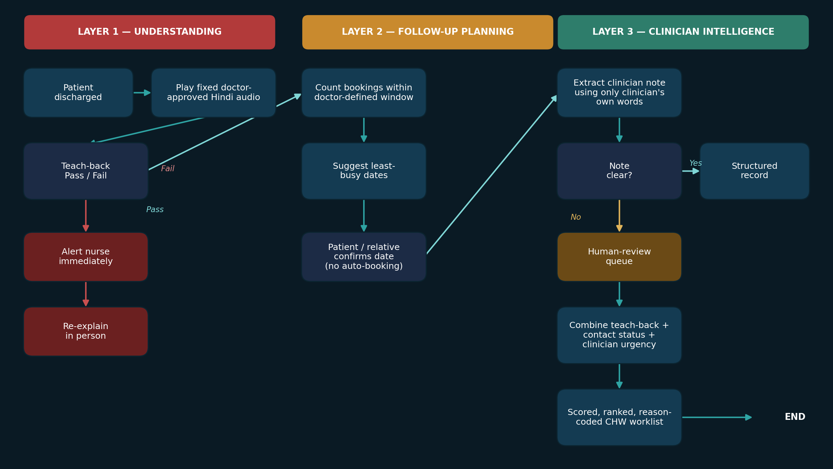
AI role: plays a fixed template, scores a Pass/Fail answer, counts existing bookings to suggest quiet dates, extracts only words the clinician actually wrote, and computes a transparent rule-based score. Human role: approves the template content, sets the safe follow-up window, writes the urgency note, confirms the final date, resolves every unclear note and every failed teach-back, and decides who to actually call from the worklist.

6. Verify — Acceptance Approach
- Baseline comparison: current manual process (no prioritisation, ad-hoc calling order) vs. worklist-ordered calling, on the same synthetic patient set.
- Outcome metric: for a fixed calling-time budget, the share of high-risk synthetic patients (by the scoring formula) actually reached, worklist-ordered vs. unordered.
- Harm / exclusion metric: rate of unclear clinician notes routed to human review (should be non-zero and visible — a 0% rate would suggest the system is silently guessing).
- Validity check (flagged as a known gap): whether teach-back Pass/Fail actually correlates with the EM-TeBa four-domain comprehension score has not yet been tested and should precede any claim that the fixed-template approach preserves EM-TeBa's effect size.

7. Scope and Boundary
In scope | Out of scope (hard rule)
Fixed, doctor-approved Hindi teach-back with Pass/Fail capture | Diagnosing, triaging, or changing treatment
Least-busy-date suggestion inside a doctor-set window; patient confirms | Automatic appointment booking
Structured extraction of only what the clinician wrote | Inventing or inferring clinical urgency
Scored, reason-coded worklist for records/CHW staff | Deciding who gets called, or replacing CHW judgement
Full audit log of every system action | Any real patient data in the Round 1 prototype

8. References
- AI Synergy Hackathon 2026, Round 1 Participant Case File (ABV-IIITM Gwalior / Sangillence) — Case 03: Healthcare, "The Follow-Up Blind Spot." Source of all CASE EVIDENCE in this brief.
- Mahajan M, Hogewoning JA, Zewald JJA, Kerkmeer M, Feitsma M, van Rijssel DA. The impact of teach-back on patient recall and understanding of discharge information in the emergency department: the Emergency Teach-Back (EM-TeBa) study. Int J Emerg Med. 2020;13:49. doi:10.1186/s12245-020-00306-9
- Haimovich AD, Mulqueen S, Carreras-Tartak J, et al. Discharge instruction comprehension by older adults in the emergency department: a systematic review and meta-analysis. Acad Emerg Med. 2024;31(11):1165–1172.
- Oh EG, Lee HJ, Yang YL, Kim YM. Effectiveness of discharge education with the teach-back method on 30-day readmission: a systematic review. J Patient Saf. 2021;17(4):305–310.
- Yen PH, Leasure AR. Use and effectiveness of the teach-back method in patient education and health outcomes. Fed Pract. 2019;36(6):284–289.
- Agency for Healthcare Research and Quality (AHRQ). Health Literacy Universal Precautions Toolkit, 2nd ed., Tool #5 — Use the Teach-Back Method. Rockville, MD: AHRQ, 2020. ahrq.gov/health-literacy/improve/precautions/tool5.html
- Gurol-Urganci I, de Jongh T, Vodopivec-Jamsek V, Atun R, Car J. Mobile phone messaging reminders for attendance at healthcare appointments. Cochrane Database Syst Rev. 2013;(12):CD007458.
- Werner K, Alsuhaibani SA, Alsukait RF, et al. Behavioural economic interventions to reduce health care appointment non-attendance: a systematic review and meta-analysis. BMC Health Serv Res. 2023;23:1136.
- Singh G, Manjunatha N, Rao S, et al. Use of mobile phone technology to improve follow-up at a community mental health clinic: a randomized control trial. Indian J Psychol Med. 2017;39(1).
- Murthy N, Chandrasekharan S, Prakash MP, et al. Effects of an mHealth voice message service (mMitra) on maternal health knowledge and practices of low-income women in India. BMC Public Health. 2020;20:820.
- Sambasivan N, Checkley G, Batool A, et al. "Privacy is not for me, it's for those rich women": performative privacy practices on mobile phones by women in South Asia. Proc. SOUPS 2018:127–142.
- World Health Organization. WHO Guideline: Recommendations on Digital Interventions for Health System Strengthening. Geneva: WHO, 2019. ISBN 978-92-4-155050-5.
- Government of India. Digital Personal Data Protection Act, 2023; Digital Personal Data Protection Rules, 2025 (notified Nov 2025).
Reused assets declaration: the three-layer workflow diagram above is original to this submission, drawn from the team's own SRS. The EM-TeBa figures and quoted statistics are reproduced from the cited open-access paper (CC BY 4.0) with attribution.

